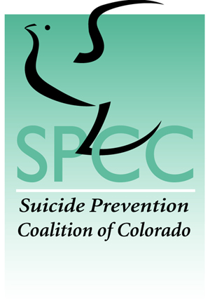
Suicide Prevention Coalition of Colorado
Presentation Request Form

Please fill out this form and email it to the SPCC Board Chair, at info@suicidepreventioncolorado.org, to schedule a presentation. Email or call 720-352-7505 with any questions.

Contact Information
Name:
Phone:
Email address:
Street Address:

Presentation Information
Presentation address:
Presentation topic: (If you are unsure of what specific topic(s) you would like covered, please see the list of potential topics below.)
Anticipated length of presentation:
Audience for presentation:
Approximately, how many audience members are you anticipating?
Will you provide access to a computer, projector and screen for visual aids?
General Information
How did you hear about the Suicide Prevention Coalition of Colorado?
What additional information should our speaker(s) know prior to presenting?

Potential Presentation Topics
General suicide prevention information (warning signs, risk factors, how to help someone at risk, suicide in Colorado)
Suicide statistics – nationally, regionally, in Colorado
Youth suicide prevention
Suicide in colleges/universities
Mental health and suicide prevention
Older adults and suicide
Suicide and the military
Suicide in the workplace
Men and suicide
Women and suicide
After a suicide – A survivor’s perspective
Suicide and addiction
A faith-based perspective on suicide prevention

SPCC can help connect you to trainers who conduct a variety of longer training sessions. Please indicate if you are interested in the following:
QPR Training
safeTALK
ASIST

